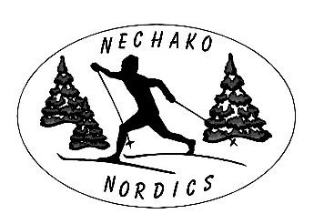

Nechako Nordics 2022 COVID-19 Safety Plan October 27, 2021
This Safety Plan has been developed based on the Northern Health Regulations introduced on October 21, 2021.

If you choose to participate in any of the Nechako Nordic programs, you must follow these rules:
- If you don’t feel well or are displaying symptoms of COVID-19, you must stay home.

- If you have traveled outside of Canada, you must self-isolate for a minimum of 14 days.

- If you live in a household with someone who has COVID-19 or is showing symptoms of COVID-9, you must stay home.

- Wash your hands before participating

- Bring your own equipment, water bottle and hand sanitizer

- Comply with 2 m physical distancing measures at all times

- Avoid physical contact with others, including shaking hands, high fives, etc.

- Leave the ski area as quickly as possible after you finish

Clubhouse use:
- Until further notice the Clubhouse will be used for essential purposes only. Unfortunately, the Clubhouse cannot be used as a gathering spot as it has been in the past.

- To avoid congestion, you will need to enter the Clubhouse from the North door and exit via the South door.

- Use of the clubhouse will be restricted to essential warm up and bathroom use only.

- We ask all users to restrict essential Clubhouse use to 15 minutes or less.

- When parents are not using the Clubhouse for essential use, they are asked to either ski the NVSA trails (if they are a member of the NVSA) or stay in their vehicles.

- All Clubhouse users must sanitize their hands as you enter and before you leave the clubhouse.

- Within the Clubhouse users must social distance appropriately allowing a minimum of 2 m distancing from all other users.

- Volunteers will be assigned to clean taps, light switches, counters, toilet and door handles and any used rental boots with a suitable disinfectant before and after lessons.

- Masks must be used inside the Clubhouse and in the Ski Equipment Shed/Stadium area.

Coaches and Helpers:
- All Nechako Nordic coaches and helpers must provide proof of being fully vaccinated.

- As all Bunnies must be supported and accompanied by an adult, this helper must also provide proof of being fully vaccinated.

Ski Rental Program:
- All helpers and anyone aged 12 and up wishing to rent ski equipment must provide proof of being fully vaccinated.

While we are all doing our best to minimize the risk of exposure to COVID-19, while the virus circulates in our communities it is impossible to completely eliminate the risk. Each participant must make their own decision as to whether it is in their best interest to resume participation at this time. You must take into account your own circumstances and make the decision that is right for you. Should you choose to join us, we require your full cooperation with our Nechako Nordics 2022 COVID-19 Safety Plan.

During the skiing season this Safety Plan will be reviewed and modified, as necessary.

