

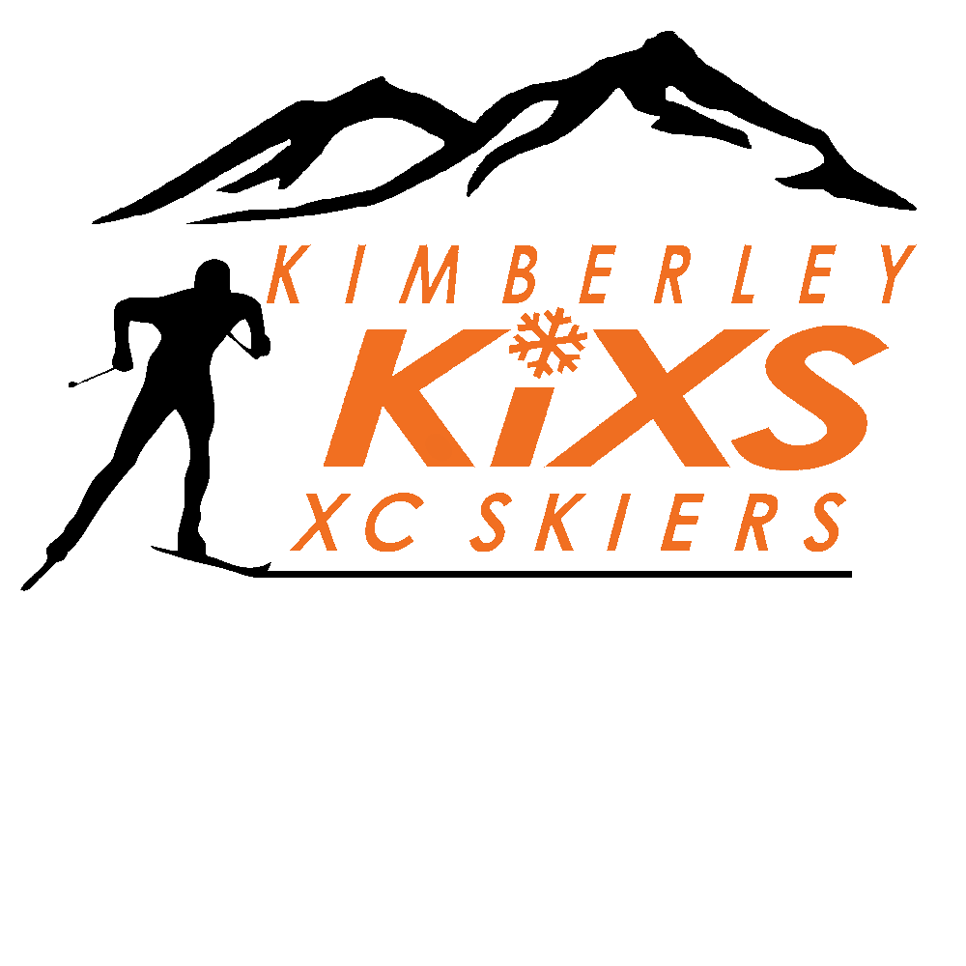
TECK REGIONAL FALL DRYLAND CAMP (KOOTENAY)

At the KIMBERLEY NORDIC CLUB
September 29th- October 1ST, 2017

Time to kick-start the fall season with a multi-day camp that will include some roller skiing, ski striding, circuit training, team bonding, and piles of FUN! Join us in Kimberley for some great training, fun outdoor activities and sports-related lectures from our special guests.

Location: Kimberley, BC, at the Kimberley Nordic Club (KNC). The lodge will remain open all weekend. You can tent or set up a trailer in the stadium area or parking lot. No water or electrical hook-ups available. Note, bears can be in the area. Some activities will start from the lodge, but roller skiing will mainly occur on the Rails to Trails, requiring transport/car-pooling to the trails. Some parent volunteers will be needed.
Athletes: This camp is open to skiers aged 8-80, but will focus on the ages of 9-14, and 15-18. Based on the Long Term Athlete Development model, athletes in the Learn to Train, Train to Train and Learn to Compete stages of development will benefit most from this camp. The camp is also open to any interested Masters athletes.

Parents: If your athlete is 12 years of age and younger, you are required to sleep on site with your athlete or find another adult to help supervise.

Local athletes are encouraged to stay on site for the duration of the camp.

Please leave electronic devices at home for the weekend! (You’ll have so much fun that you won’t miss them!)

Coaches: Graham MacLean and Frank Ackermann

Parents:
We are looking for volunteers in varying capacities:
- Group Sweeps in runs, ski striding, roller skiing; lead or assist in games and team building activities; dinner prep and clean up on Saturday; clean up after the camp.
- Parent coaches/coaches please come and learn alongside other coaches. We would like to have an opportunity for you to learn and develop as well in a mentorship setting.
- If you are on our volunteer coach list, we will cover the cost for your Saturday evening meal. Contact Frank Ackermann to be placed on this list.

Registration & Cost:

The focus for this camp is FUN, as well as time to bond with your teammates. Athletes are expected to demonstrate respectful, supportive and inclusive behaviour at all times. Coaches and/or chaperones will supervise athletes during the daytime activities. Parents and/or chaperones will be responsible for all meal times other than Saturday dinner, as well as evening/nighttime supervision.

Registration and payment is on zone4 at https://zone4.ca, and the deadline to register is September 25th. For registration inquiries, please contact frankackermann@me.com

Cost for the camp is $60 for athletes of all ages. The fee includes rental of the lodge, snacks and electrolyte drinks on all days for the athletes, dinner on Saturday night, and the cost for our 2 guest lecturers on Friday and Saturday evenings. For parents/guests not registered for the camp, dinner tickets will be available through zone4.ca at $20 per person. Please bring your own dishes and cutlery. Everyone will be responsible for all of their own breakfasts and lunches, as well as dinner on Friday night.

Teck will be awarding athletic T-Shirts to participants aged 16 and under.

This camp has a full participation policy. This means that participants are expected to arrive when the camp starts on Sept 29th and stay until the camp ends on October 1th unless you have made prior arrangements with Frank Ackermann.

Tentative Training and Activity Times:
Friday: 3:30pm – arrive at the KNC and set up your tents/check-in with the coaches
4:00pm – 6:00pm – fun team-bonding activity followed by ski striding for all groups
6:00pm – 6:30pm – guest lecture

Saturday: 7:30am – 7:45am - morning activation run
9:00am – 12:00 - carpool to roller-ski venue. Older athletes will do some slow technique-focused skiing and video analysis, followed by a skate time trial up Gerry Sorensen Way (3.5km uphill time trial); younger athletes/beginners will roller-ski and compete in a fun obstacle course
12:00pm – 1:00pm – lunch (on your own)
1:00pm - 2:00pm – quiet time and rest
2:00pm – 2:45pm – run down to Chapman Camp Field (Giegerich Field) through the Nature Park
2:45pm – 4:00pm - Ultimate Frisbee
4:00pm - 5:00pm – Classic or skate roller-ski back up to the KNC lodge
5:30pm - 6:00pm – guest lecture
6:15pm – 8:00pm – dinner at the KNC lodge
8:00pm – 9:00pm – campfire stories
Sunday: 7:30am – 7:45am - morning activation run
9:00am – 9:30am – circuit training for 30min
9:45am – 12:30pm - 20km trail run in the Kimberley Nature Park for older athletes, and younger athletes will have an intro to Orienteering followed by an orienteering competition on the Nordic Trails.
12:00pm – lunch and clean-up prior to departure

What to Bring:

***Please have all items well marked with first and last name and club***
- B.C. Care Card/Medical number
- Personal hygiene items (toothbrush, toothpaste, deodorant, etc.)
- Sunscreen and lip balm with sun block
- Sunglasses
- Towels (suggest bringing one for indoor and one for outdoor use)
- Rain Jacket and Pants.
- Training clothes for very hot through to cold, wet and miserable weather
- Camping supplies (i.e. tent, sleeping bag, thermarest, pillow, chairs, cooking and eating utensils, etc.)
- Socks (lots of extra socks in case of wet weather)
- Shorts/pants/sweatshirt/t-shirt (casual clothes)
- Hats (baseball cap and toque)
- Gloves for roller skiing and for being outside in other training
- Day pack suitable for hiking and moving your items to offsite training locations
- Running shoes
- Ski striding poles (10 cm shorter than regular classic poles - i.e. mid-chest height)
- Heart rate monitor (for athletes 14 and older)
- Water bottles/water belts
- Headlamp and batteries
- Small personal first aid kit
- Homework
- Yoga mat or foamy
- Skate roller ski equipment (ALL)
  - Includes: roller skis (roller-blades acceptable for younger or beginners; and if you have both classic and skate roller skis, bring them both), poles with carbide tips, boots, helmet, reflective vest, gloves

*Reflective vests or HI VIS T-shirts and helmets are MANDATORY for roller ski sessions.
*You will not be allowed to participate in roller ski sessions if you do not have them.

Please refrain from bringing any electronic devices for the duration of the camp - there is no Internet access at the campground. Electronic games, videos, etc. will not be permitted during the camp.

See you in Kimberley!

